Project Development Phase
Functional & Performance Testing – GenAI-Style Template
Implement Client Script & UI Policy (Incident)
Date | 1 October 2026
Team ID | SWTID-2026-4755
Project Name | Implement Client Script & UI Policy (Incident)
Maximum Marks | 10 Marks
1. Project-specific test context
This Incident project does not use GenAI. The report type is adapted to test functional outcomes plus interaction performance of deterministic ServiceNow client controls.
The project uses a ServiceNow Incident form and list with one High Impact Control UI Policy and three Client Scripts. The test focus below adapts the ZIP reference report type to the Incident project; it does not claim that a live execution was completed during report preparation.
3. Test scenarios and results
Test Case ID | Scenario | Test Steps | Expected Result | Actual Result | Status
FT-01 | High-impact policy activation | Set Impact to High on an Incident. | Assignment group is mandatory and Urgency is read-only. | Pending execution | Pending
FT-02 | Urgency automation | Change Impact to High and observe message. | Urgency becomes 1 and information message appears. | Pending execution | Pending
FT-03 | Save validation | Submit with Impact High and Assigned To empty. | Error appears and save is prevented. | Pending execution | Pending
FT-04 | Successful save | Select Assigned To and submit. | Incident saves without error. | Pending execution | Pending
FT-05 | List State protection | Double-click State in Incident list. | Alert appears and edit is rejected. | Pending execution | Pending
FT-06 | Form State update | Change State from the Incident form and click Update. | Form-based update saves successfully. | Pending execution | Pending
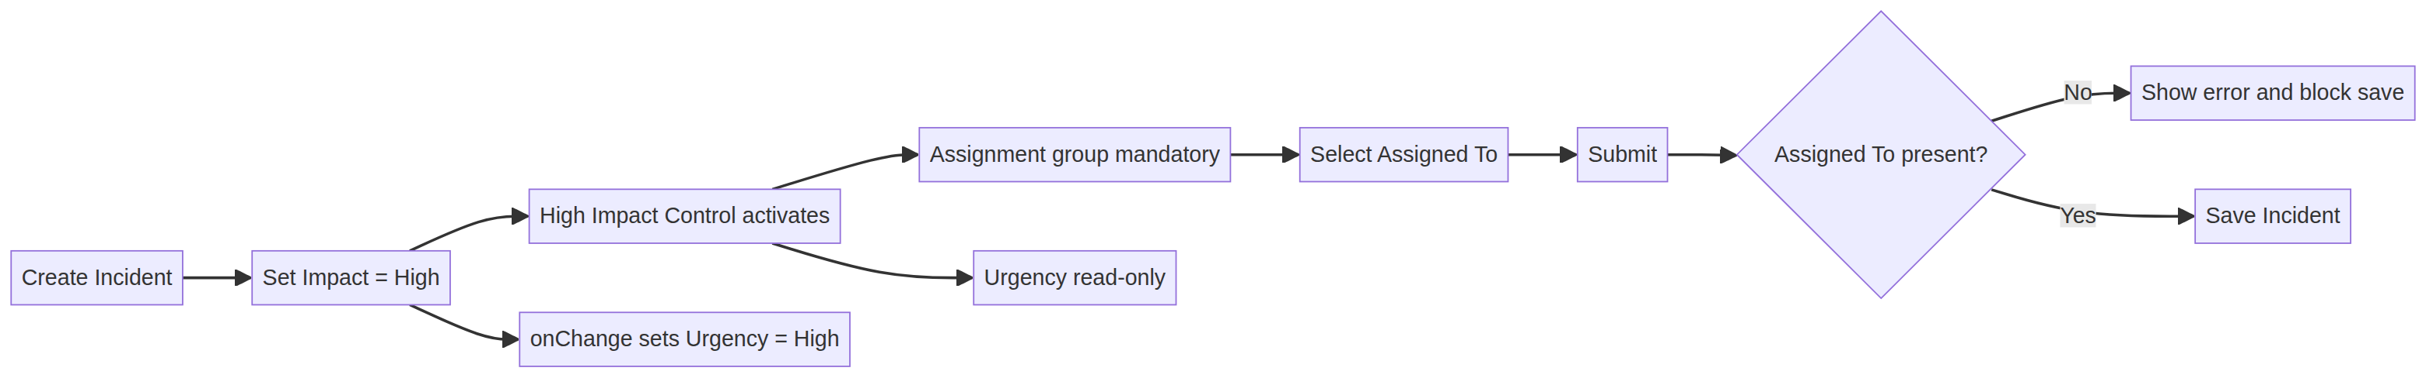
Original project-specific visual created for this Incident report.
4. Interpretation and evidence note
The actual result column must be completed during execution. The expected results are taken from the Incident project specification, not invented runtime evidence.
5. Execution status
Status at report preparation: Pending execution in the target ServiceNow instance. The source project PDF defines the configuration and expected behavior, but does not include live screenshots, response-time logs, or execution timestamps. Record those artifacts against each test case before final sign-off.
6. Conclusion
This report provides a project-specific Phase 5 testing baseline for Implement Client Script & UI Policy (Incident). The selected scenarios verify conditional field behavior, urgency automation, save-time validation, list-edit protection, and form-based updates while preserving the traceability expected in the supplied reference reports.

